NAHC  2024 | 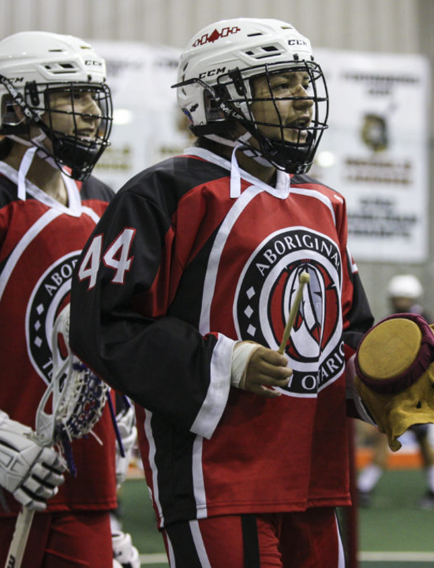
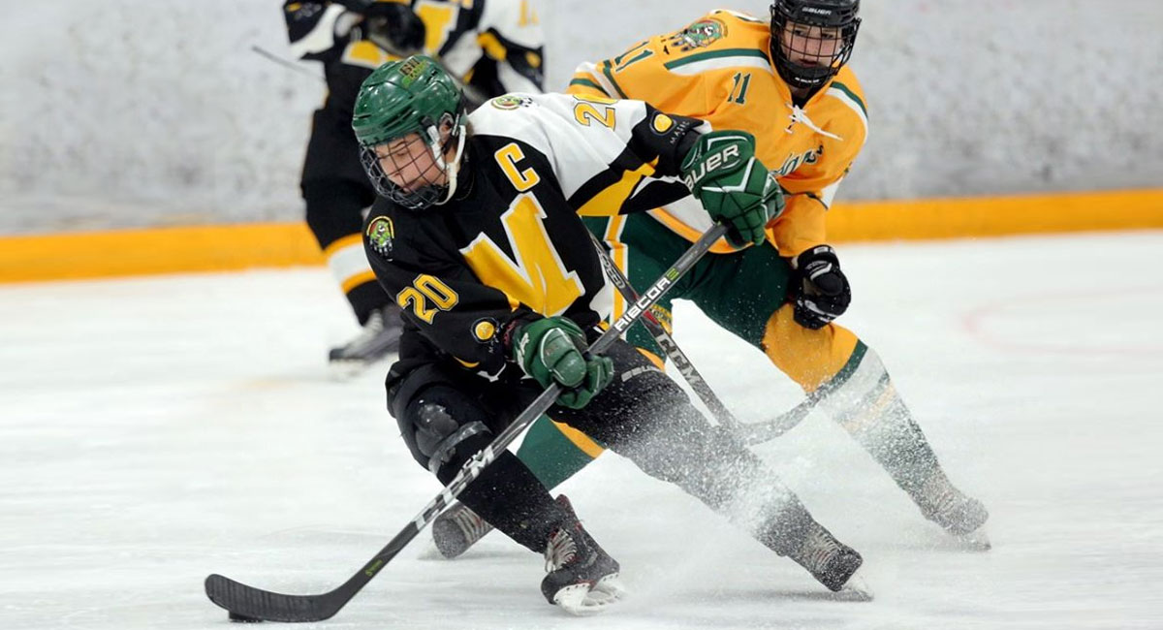

Bid submission form

NAHC 2024

Bid submission Form

Using This Form

Click or tap to add text.

To create a new line/paragraph break, use “SHIFT+ENTER”

If you do not wish to use this form, the submitted bid must follow this format. This will allow for better comparison when bids are in the ranking and selection phase.

NOTE: An asterisk* indicates that there is more information about the section in the “Bid Submission Guide”

If you have any questions regarding the Bid Submission Form, please email Attn: NAHC Bid Coordinator at rfp@aboriginalsportcircle.ca

NAHC 2024 Bid Submission

Submitted By: Click or tap here to enter text.

On Behalf Of: Click or tap here to enter text.

On This Date: Click or tap here to enter text.

Section A: Event Details
This section shows details regarding infrastructure and facilities that can support the event in your community.
A.1* | Proposed Event Dates  Click or tap here to enter text.
A.2* | Host Community Name  Click or tap here to enter text.
A.2.a* | Host Community’s Average Temperature/Meteorology in May  Click or tap here to enter text.
A.2.b* | Host Community Demographics  Area  Click or tap here to enter text.  Population  Click or tap here to enter text.  Cultural Profile  Click or tap here to enter text.  Traditional Indigenous Peoples/Territory  Click or tap here to enter text.
A.2.c | Host Community Attractions (restaurants, art galleries, museums, shopping, etc.):  ☐ Restaurants: Click or tap here to enter text.  ☐ Art Galleries: Click or tap here to enter text.  ☐ Museums: Click or tap here to enter text.  ☐ Shopping: Click or tap here to enter text.  ☐ Other: Click or tap here to enter text.
A.3 | Event Venue(s) Name and Address (Note: venue details to be entered in Section D)  Venue #1  Name: Click or tap here to enter text.  Address: Click or tap here to enter text.  Venue #2  Name: Click or tap here to enter text.  Address: Click or tap here to enter text.  Venue #3  Name: Click or tap here to enter text.  Address: Click or tap here to enter text.
A.4* | Local Airport  Name and Address  Click or tap here to enter text.  Typical Number of Daily Inbound Flights in March  Click or tap here to enter text.  Percentage of Cancelled Flights in March  Click or tap here to enter text.  Main Feed-In Hubs (Toronto, Calgary, Vancouver, etc.)  Click or tap here to enter text.  Largest Plane Size/Type that can be accommodated  Click or tap here to enter text.
A.4.a* | Optional Methods of Host Community Access (e.g., nearby airports and transfers, etc.)  Click or tap here to enter text.
A.5* | Proposed Hotels (confirm hold by May 30, 2023)
A.5.a | Hotel #1  Name: Click or tap here to enter text.  Address: Click or tap here to enter text.  Number of Double Occupancy Rooms: Click or tap here to enter text.  Distance from Airport: Click or tap here to enter text.  Distance from Event Venue: Click or tap here to enter text.  Hotel Website: Click or tap here to enter text.
A.5.b | Hotel #2  Name: Click or tap here to enter text.  Address: Click or tap here to enter text.  Number of Double Occupancy Rooms: Click or tap here to enter text.  Distance from Airport: Click or tap here to enter text.  Distance from Event Venue: Click or tap here to enter text.  Hotel Website: Click or tap here to enter text.
A.5.c | Hotel #3  Name: Click or tap here to enter text.  Address: Click or tap here to enter text.  Distance from Airport: Click or tap here to enter text.  Distance from Event Venue: Click or tap here to enter text.  Hotel Website: Click or tap here to enter text.
A.5.d | Hotel #4  Name: Click or tap here to enter text.  Address: Click or tap here to enter text.  Number of Double Occupancy Rooms: Click or tap here to enter text.  Distance from Airport: Click or tap here to enter text.  Distance from Event Venue: Click or tap here to enter text.  Hotel Website: Click or tap here to enter text.
A.5.e | Additional Hotel Information on Separate Sheet?  ☐ Yes ☐ No
A.6 | Local Transportation Options
A.6.a | Bus Line #1  Name and Address: Click or tap here to enter text.  Size of Fleet: Click or tap here to enter text.  Website: Click or tap here to enter text.
A.6.b | Bus Line #2  Name and Address: Click or tap here to enter text.  Size of Fleet: Click or tap here to enter text.  Website: Click or tap here to enter text.
A.6.c | Bus Line #3  Name and Address: Click or tap here to enter text.  Size of Fleet: Click or tap here to enter text.  Website: Click or tap here to enter text.
A.6.d | Additional Bus Line Information on Separate Sheet?  ☐ Yes ☐ No
A.6.e* | Ride Share Available? If yes, list companies  Click or tap here to enter text.
A.6.f | Other transportation options (public transportation, etc.)  Click or tap here to enter text.
A.7* | Hospitals and Clinics (names, addresses and websites)  Click or tap here to enter text.
A.8* | Major Events Previously Hosted in Host Community  Click or tap here to enter text.
A.9* | Commitment to Form a Host Society  The successful bidder must create a standalone not-for-profit corporation with which the ASC will contract to mount the event. (See Bid Manual for further detail on qualifications)  The bidder agrees to the above: ☐ Yes ☐ No  Notes Click or tap here to enter text.  Proposed or Existing Host Society Organizational Structure  Click or tap here to enter text.
A.10 | Insurance  Certificate of insurance to be submitted to the ASC no later than June 30, 2023. Note: Insurance must include coverage specific to special events.  The bidder or Host Society can attain 5M minimum in Commercial General Liability (CGL) Insurance  ☐ Yes ☐ No
Section B: Event Vision
This section outlines your vision for the participants’ and community’s’ experience and engagement as well as the direct and indirect impacts and legacies of the event.
B.1* | Host Objectives  Click or tap here to enter text.
B.2* | Community and Government Support  Indigenous Leadership and Community Support  Click or tap here to enter text.  Council or other Government Support  Click or tap here to enter text.  Governmental Financial Support  Click or tap here to enter text.  Other Financial Support  Click or tap here to enter text.  Media Support  Click or tap here to enter text.  Business Community Support (Financial or In-Kind)  Click or tap here to enter text.  Community Services Group Support  Click or tap here to enter text.  Volunteer Organizations Support  Click or tap here to enter text.
B.3 | Opening Ceremonies  Click or tap here to enter text.
B.4 | Closing Ceremonies  Click or tap here to enter text.
B.5 | Proposed Organized Social Event (s):  Click or tap here to enter text.
B.5.a | Event Description #1  What: Click or tap here to enter text.  Who will attend: Click or tap here to enter text.  Proposed Date: Click or tap to enter a date.
B.5.b | Event Description #2  What: Click or tap here to enter text.  Who will attend: Click or tap here to enter text.  Proposed Date: Click or tap to enter a date.
B.5.c | Additional Organized Social Event Information on Separate Sheet?  ☐ Yes ☐ No
B.6* | Cultural Experiences Available in Host Community  Click or tap here to enter text.
B.7* | Community Engagement  Click or tap here to enter text.
B.8* | Legacy Statement  Click or tap here to enter text.
B.9* | Event Capture  Click or tap here to enter text.
Section C: Event Planning
Note: Only a high-level overview of proposed approach to staging NAHC 2024 is required in the Bid Submission. It is highly recommended that the “Bid Submission Guide” is referred to when filling out this section.
C.1* | Accommodation and Hospitality Plan (detailed plan due June 30, 2023)  Click or tap here to enter text.
C.2* | Budget (detailed budget due June 20, 2023, detailed update due September 30, 2023)  Click or tap here to enter text.
C.3* | Communications, Marketing and Promotion Plan (preliminary plan due June 30, 2023, final plan due September 30, 2023)  Click or tap here to enter text.
C.4* | Event Medical Services and Support (detailed plan due September 30, 2023, update due March 31, 2024)  Click or tap here to enter text.
C.5* | Safety, Security and Risk Plan (detailed plan due June 30, 2023, update plan due September 30, 2023 detailed plan due January 30, 2024)  Click or tap here to enter text.
C.6* | Sponsorship and Revenue Generation Plan (detailed plan due June 30, 2023, detailed update due September 30, 2023)  Click or tap here to enter text.
C.7* | Transportation Plan (preliminary plan due June 30, 2023, detailed plan due January 31, 2024)  Click or tap here to enter text.
C.8* | Volunteer Engagement Plan (preliminary plan due June 30, 2023, interim plan due September 30, 2023, final plan due January 30, 2024)  Click or tap here to enter text.
C.9* | Venue Amenities and Usage (detailed plan due September 30, 2023)  Click or tap here to enter text.
Section D: Competition Venues
Note: Floor plans in pdf format are required with Bid Submission
D.1 |  | Rink #1 Name: Click or tap here to enter text.
D.2.a |  | Rink Address: Click or tap here to enter text.
D.2.b |  | Rink Website: Click or tap here to enter text.
D.2.c |  | Dates Held (Must be available 1 full day prior to Event Start Date):  Start: Click or tap to enter a date.  Finish: Click or tap to enter a date.
D.2.d |  | Exclusivity (Confirm no other groups or events scheduled facility use)  Is the facility booked immediately before NAHC?  ☐ Yes ☐ No Explain: Click or tap here to enter text.  Is it a type of event that, due to postponements, scoring draws, etc., conflict with NAHC starting dates?  ☐ Yes ☐ No Explain: Click or tap here to enter text.
D.2.e |  | Ice Surface(s) Size: Click or tap here to enter text.
D.2.f |  | Venue Amenities Available to Event:  ☐ Equipment Storage: Click or tap here to enter text.  ☐ Drying Facilities: Click or tap here to enter text.  ☐ Skate Sharpening: Click or tap here to enter text.  ☐ Sports Shop: Click or tap here to enter text.  ☐ Concession: Click or tap here to enter text.  ☐ Public Announcement System: Click or tap here to enter text.  ☐ Electronic Scoreboard: Click or tap here to enter text.  ☐ Box Office: Click or tap here to enter text.  ☐ Parking: Click or tap here to enter text.  Wheelchair Accessibility For  ☐ Venue: Click or tap here to enter text.  ☐ Dressing Rooms: Click or tap here to enter text.  ☐ Rink Side: Click or tap here to enter text.
D.2.g |  | Seating Capacity (number of seats): Click or tap here to enter text.
D.2.h |  | Seating Style (theatre, bench): Click or tap here to enter text.
D.2.i |  | Viewing Boxes/Suites Available:  ☐ Yes ☐ No  Number Available to Event: Click or tap here to enter text.
D.2.j |  | Number of Dressing Rooms: Click or tap here to enter text.
D.2.j.a |  | Teams will have dedicated dressing rooms throughout event  ☐ Yes ☐ No
D.2.j.b |  | Dressing Room #1  Size: Click or tap here to enter text.
D.2.j.c |  | Dressing Room #2  Size: Click or tap here to enter text.
D.2.j.d |  | Dressing Room #3  Size: Click or tap here to enter text.
D.2.j.e |  | Dressing Room #4  Size: Click or tap here to enter text.
D.2.j.f |  | Dressing Room #5  Size: Click or tap here to enter text.
D.2.j.g |  | Dressing Room #6  Size: Click or tap here to enter text.
D.2.j.h |  | Dressing Room #7  Size: Click or tap here to enter text.
D.2.j.i |  | Dressing Room #8  Size: Click or tap here to enter text.
D.2.j.l |  | Additional Dressing Room Size Information on Separate Sheet?  ☐ Yes ☐ No
D.2.k* |  | Medical Facilities (on-site)  Click or tap here to enter text.
D.2.l* |  | Venue *Advertising Capabilities  Click or tap here to enter text.
D.2.m* |  | Multi-Purpose Rooms  Click or tap here to enter text.
E. Authorization to Place Bid
I confirm that I have the authorization to place this bid on the behalf of Click or tap here to enter text.
Signature: (electronic signatures accepted)

